Robust clipped correlation: EURUSD and AUDUSD
Method 04 / daily log returns clipped at ±0.01, ±0.02, ±0.03 / Alpari D1 full available history

Study setup
Logical pair: EURUSD , AUDUSD
Broker symbols: EURUSD_i , AUDUSD_i
Snapshot: 2026-11-03_majors_alpari_D1
Timeframe: D1
Matched return window: 1999-01-05 to 2026-11-02 (UTC bar dates)
Matched return count n: 7201
Dropped unfinished last bar dated 2026-11-03 UTC after a tick-volume check against the prior complete day.
Clip bounds c in log-return units: 0.01, 0.02, 0.03 (about ±1%, ±2%, ±3% on the log scale). Headline c = 0.02.
Clipping caps a day's magnitude at ±c and keeps the row; it does not drop the day, so n is the same at every c.
Complete matched rows (Excel): EURUSD-AUDUSD_Clipped_D1.xlsx
Complete matched rows (HTML table): EURUSD-AUDUSD_Clipped_D1_data.html

Method carried forward
Each matched daily log return of close, ln(close_t / close_t-1), is clipped in the broker quote direction before Pearson correlation: x_tilde = min(c, max(-c, x)) and y_tilde = min(c, max(-c, y)), then rho_clip = Pearson(x_tilde, y_tilde) on the same rows as raw Pearson r. Quotes are not inverted. A day beyond ±c stays in the sample at the cap; n does not change. rho_clip is symmetric under swap of the two symbols. rho_clip = 0 means no straight-line link among the clipped values in this sample; it does not mean no link of any kind. The score is not a cause, not a lead, and not a trading signal. Daily rows are not independent draws, so the two-sided p-value and Fisher interval are reported and treated as secondary to rho_clip. Cap-hit counts (|log return| > c) flag how much of each leg was capped.

Raw Pearson on the same rows
Pearson r: 0.556324
Two-sided p-value: 0
Approximate 95% Fisher interval: [0.540167, 0.572070]
This is the unclipped comparison required by the method. The headline score is rho_clip at c = 0.02 below.

Clipped results
n = 7201 at every c. Headline row is c = 0.02. Cap-hit count is the number of days with |log return| > c before clipping.
c | rho_clip | p | ci_low | ci_high | rho_minus_r | EURUSD_cap_hits | AUDUSD_cap_hits | EURUSD_cap_share | AUDUSD_cap_share
0.01 | 0.550664 | 0 | 0.53436355 | 0.56655598 | -0.0056593709 | 622 | 978 | 0.086377 | 0.135814
0.02 | 0.563344 | 0 | 0.5473691 | 0.57890913 | 0.0070204444 | 41 | 130 | 0.005694 | 0.018053
0.03 | 0.564695 | 0 | 0.54875451 | 0.5802242 | 0.0083707175 | 4 | 34 | 0.000555 | 0.004722

Conclusion
Over 7201 matched daily log-return rows for EURUSD and AUDUSD (broker quote directions unchanged), headline robust clipped correlation at c=0.02 is 0.5633 (positive, moderate straight-line association among clipped values in this sample). Approximate 95% Fisher interval on the clipped series: [0.5474, 0.5789]. Same-sample raw Pearson r is 0.5563 (rho_clip minus r = 0.0070). Sensitivity across the fixed grid: c=0.01 same sign; c=0.02 same sign; c=0.03 same sign. Two-sided p under the usual independent bivariate-normal model is 0; that model does not match linked daily FX returns, so treat p as secondary. This does not establish cause, lead-lag, or a lasting trading rule.

What to look at in this file next time
1) rho_clip at c = 0.02 versus raw Pearson r. 2) Whether c = 0.01 and c = 0.03 keep the same sign as 0.02. 3) Cap-hit counts before treating a large gap as settled. 4) The ±0.02 lines on the returns chart and the clip box on the scatter.

Charts
Daily closes

Daily log returns with +/- 0.02 clip lines
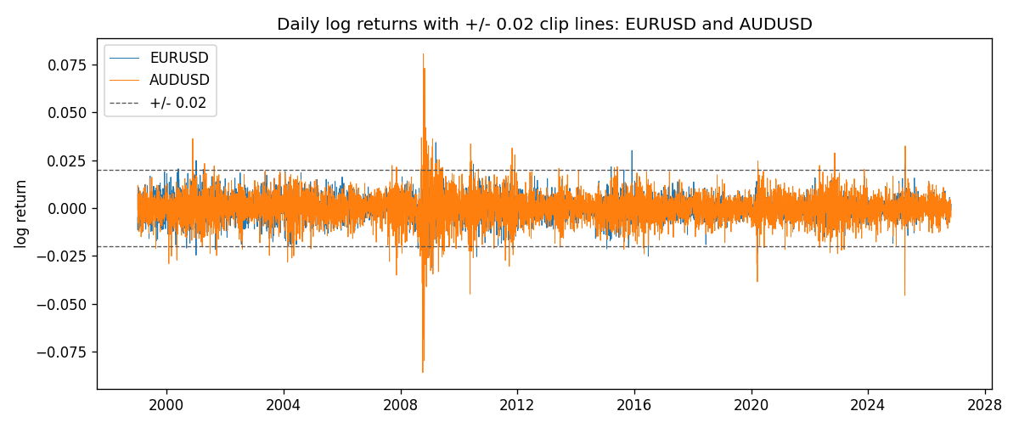
Log-return scatter with +/- 0.02 clip box
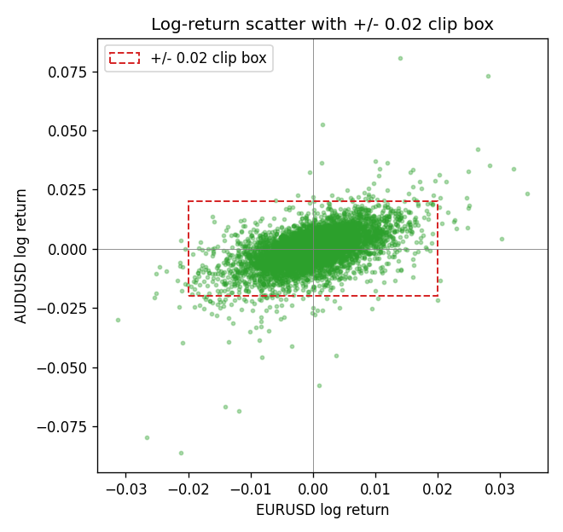

Data report
Every matched row that entered the clipped and raw correlations is stored in the sibling Excel workbook named EURUSD-AUDUSD_Clipped_D1.xlsx. That file is the complete data archive for redrawing charts. Embedding all rows as a Word table is impractical at this length; the Word file holds the column list, column summaries, and the first and last 15 matched rows.
Columns: time, EURUSD_open, AUDUSD_open, EURUSD_high, AUDUSD_high, EURUSD_low, AUDUSD_low, EURUSD_close, AUDUSD_close, EURUSD_tick_volume, AUDUSD_tick_volume, EURUSD_spread, AUDUSD_spread, EURUSD_real_volume, AUDUSD_real_volume, EURUSD_log_return, AUDUSD_log_return, EURUSD_log_return_clip_0p01, AUDUSD_log_return_clip_0p01, EURUSD_log_return_clip_0p02, AUDUSD_log_return_clip_0p02, EURUSD_log_return_clip_0p03, AUDUSD_log_return_clip_0p03
Column summaries (matched calculation rows)
column | count | mean | std | min | 25% | 50% | 75% | max
EURUSD_open | 7201 | 1.1813268 | 0.15086382 | 0.8272 | 1.08608 | 1.16615 | 1.29393 | 1.5995
AUDUSD_open | 7201 | 0.75197127 | 0.13525779 | 0.4785 | 0.66105 | 0.73142 | 0.80912 | 1.10284
EURUSD_high | 7201 | 1.1864593 | 0.1514619 | 0.8326 | 1.0902 | 1.17128 | 1.29926 | 1.6038
AUDUSD_high | 7201 | 0.75602178 | 0.13581838 | 0.4878 | 0.6647 | 0.7349 | 0.81518 | 1.10795
EURUSD_low | 7201 | 1.1763142 | 0.15018707 | 0.8227 | 1.08202 | 1.16257 | 1.28834 | 1.5865
AUDUSD_low | 7201 | 0.74791431 | 0.13457219 | 0.4775 | 0.6577 | 0.72758 | 0.8042 | 1.0975
EURUSD_close | 7201 | 1.1813656 | 0.15083992 | 0.8267 | 1.08601 | 1.16617 | 1.29395 | 1.5997
AUDUSD_close | 7201 | 0.75202148 | 0.13524071 | 0.4786 | 0.6612 | 0.73175 | 0.80916 | 1.10169
EURUSD_tick_volume | 7201 | 103004.8 | 173409.64 | 469 | 9389 | 52708 | 99441 | 1471626
AUDUSD_tick_volume | 7201 | 77347.024 | 138135.9 | 109 | 5434 | 43320 | 71320 | 1234623
EURUSD_spread | 7201 | 19.396195 | 16.574381 | 0 | 8 | 12 | 30 | 50
AUDUSD_spread | 7201 | 30.819886 | 16.887485 | 0 | 13 | 30 | 50 | 50
EURUSD_real_volume | 7201 | 4.0238636e+10 | 1.6675367e+11 | 0 | 0 | 0 | 0 | 3.6149665e+12
AUDUSD_real_volume | 7201 | 5.2420906e+09 | 1.2538049e+11 | 0 | 0 | 0 | 0 | 3.811512e+12
EURUSD_log_return | 7201 | -7.54e-06 | 0.00580172 | -0.03123819 | -0.00324684 | 0 | 0.00325501 | 0.03433183
AUDUSD_log_return | 7201 | 2.459e-05 | 0.00754509 | -0.08602525 | -0.00385511 | 0.00028229 | 0.00415126 | 0.0806166
EURUSD_log_return_clip_0p01 | 7201 | -1.002e-05 | 0.00501106 | -0.01 | -0.00324684 | 0 | 0.00325501 | 0.01
AUDUSD_log_return_clip_0p01 | 7201 | 0.00011493 | 0.00565377 | -0.01 | -0.00385511 | 0.00028229 | 0.00415126 | 0.01
EURUSD_log_return_clip_0p02 | 7201 | -1.357e-05 | 0.00571621 | -0.02 | -0.00324684 | 0 | 0.00325501 | 0.02
AUDUSD_log_return_clip_0p02 | 7201 | 5.853e-05 | 0.00682409 | -0.02 | -0.00385511 | 0.00028229 | 0.00415126 | 0.02
EURUSD_log_return_clip_0p03 | 7201 | -8.29e-06 | 0.00579575 | -0.03 | -0.00324684 | 0 | 0.00325501 | 0.03
AUDUSD_log_return_clip_0p03 | 7201 | 4.132e-05 | 0.00713389 | -0.03 | -0.00385511 | 0.00028229 | 0.00415126 | 0.03
First 15 matched rows (selected columns)
time | EURUSD_close | AUDUSD_close | EURUSD_log_return | AUDUSD_log_return | EURUSD_log_return_clip_0p02 | AUDUSD_log_return_clip_0p02
1999-01-05 | 1.1758 | 0.6215 | -0.0048360507 | -0.00080418179 | -0.0048360507 | -0.00080418179
1999-01-06 | 1.1623 | 0.6289 | -0.011547966 | 0.011836351 | -0.011547966 | 0.011836351
1999-01-07 | 1.1712 | 0.6345 | 0.0076280636 | 0.0088650256 | 0.0076280636 | 0.0088650256
1999-01-08 | 1.1585 | 0.6347 | -0.010902799 | 0.00031515916 | -0.010902799 | 0.00031515916
1999-01-11 | 1.1503 | 0.6393 | -0.007103287 | 0.0072213815 | -0.007103287 | 0.0072213815
1999-01-12 | 1.1555 | 0.6362 | 0.0045103728 | -0.0048608485 | 0.0045103728 | -0.0048608485
1999-01-13 | 1.1681 | 0.6312 | 0.010845346 | -0.0078902098 | 0.010845346 | -0.0078902098
1999-01-14 | 1.1681 | 0.6295 | 0 | -0.002696916 | 0 | -0.002696916
1999-01-15 | 1.1563 | 0.634 | -0.010153245 | 0.007123101 | -0.010153245 | 0.007123101
1999-01-18 | 1.1605 | 0.6346 | 0.0036256946 | 0.00094592471 | 0.0036256946 | 0.00094592471
1999-01-19 | 1.1603 | 0.6392 | -0.00017235436 | 0.0072225153 | -0.00017235436 | 0.0072225153
1999-01-20 | 1.1566 | 0.64 | -0.0031939256 | 0.0012507819 | -0.0031939256 | 0.0012507819
1999-01-21 | 1.1601 | 0.6405 | 0.0030215416 | 0.00078094498 | 0.0030215416 | 0.00078094498
1999-01-22 | 1.1587 | 0.6327 | -0.0012075213 | -0.012252745 | -0.0012075213 | -0.012252745
1999-01-25 | 1.1552 | 0.6302 | -0.0030251979 | -0.0039591468 | -0.0030251979 | -0.0039591468
Last 15 matched rows (selected columns)
time | EURUSD_close | AUDUSD_close | EURUSD_log_return | AUDUSD_log_return | EURUSD_log_return_clip_0p02 | AUDUSD_log_return_clip_0p02
2026-10-13 | 1.11965 | 0.69821 | 0.0037402957 | 0.0035007712 | 0.0037402957 | 0.0035007712
2026-10-14 | 1.11545 | 0.69715 | -0.0037582255 | -0.0015193215 | -0.0037582255 | -0.0015193215
2026-10-15 | 1.12172 | 0.69191 | 0.0056053107 | -0.0075447063 | 0.0056053107 | -0.0075447063
2026-10-16 | 1.12371 | 0.69426 | 0.0017724895 | 0.0033906408 | 0.0017724895 | 0.0033906408
2026-10-19 | 1.12086 | 0.6978 | -0.0025394633 | 0.0050859986 | -0.0025394633 | 0.0050859986
2026-10-20 | 1.12354 | 0.70022 | 0.0023881672 | 0.0034620426 | 0.0023881672 | 0.0034620426
2026-10-21 | 1.12318 | 0.70275 | -0.00032046717 | 0.0036066384 | -0.00032046717 | 0.0036066384
2026-10-22 | 1.12139 | 0.70186 | -0.0015949606 | -0.0012672558 | -0.0015949606 | -0.0012672558
2026-10-23 | 1.11989 | 0.70353 | -0.001338521 | 0.0023765656 | -0.001338521 | 0.0023765656
2026-10-26 | 1.11735 | 0.70128 | -0.0022706559 | -0.0032032829 | -0.0022706559 | -0.0032032829
2026-10-27 | 1.11272 | 0.70245 | -0.004152342 | 0.0016669876 | -0.004152342 | 0.0016669876
2026-10-28 | 1.1152 | 0.70533 | 0.0022262927 | 0.0040915541 | 0.0022262927 | 0.0040915541
2026-10-29 | 1.11772 | 0.70245 | 0.0022571351 | -0.0040915541 | 0.0022571351 | -0.0040915541
2026-10-30 | 1.11644 | 0.70316 | -0.0011458446 | 0.0010102376 | -0.0011458446 | 0.0010102376
2026-11-02 | 1.11881 | 0.69971 | 0.002120569 | -0.0049184984 | 0.002120569 | -0.0049184984

